Networks / PCA / connectedness: EURUSD and GBPUSD
Method 28 / pair slice of eight-major system / Alpari D1 full available history

Study setup
Logical pair: EURUSD , GBPUSD
Broker symbols: EURUSD_i , GBPUSD_i
Snapshot: 2026-11-03_majors_alpari_D1
Timeframe: D1
Matched return window: 1999-01-05 to 2026-11-02 (UTC bar dates)
Matched return count n: 7202
System panel n: 7127
Dropped unfinished last bar dated 2026-11-03 UTC after a tick-volume check against the prior complete day.
VAR lag (BIC): 1; GFEVD horizon H=10
System TCI: 54.0425
Complete matched rows (Excel): EURUSD-GBPUSD_Network_D1.xlsx

Method carried forward
Three system-level tools on the eight-major daily log-return panel. (1) Network distance d_ij = sqrt(2*(1-rho_ij)) from Pearson correlation. (2) PCA eigenvalues of the correlation matrix R (R v = lambda v). (3) Diebold-Yilmaz total connectedness index (TCI) from a VAR with generalised forecast-error variance decomposition (GFEVD), horizon H=10; lag order chosen by BIC with maxlags=10. TCI = 100 * sum_{i!=j} theta_tilde_ij / N after row-normalising GFEVD shares. Pair reports show d_ij, rho_ij, and the directed pair spillover shares from the system theta_tilde matrix. Edges and TCI are not trading signals.

Pair results
Pearson rho: 0.642007
Network distance d_ij: 0.846160
theta_tilde[EURUSD->GBPUSD] (row EURUSD, col GBPUSD): 0.133766
theta_tilde[GBPUSD->EURUSD] (row GBPUSD, col EURUSD): 0.156509
PCA lambda_1: 3.817794
PCA variance share PC1: 0.477224

Conclusion
For EURUSD-GBPUSD: d_ij=0.8462 from rho=0.6420. Pair spillover shares 0.1338 / 0.1565. System TCI=54.04. Not a trading signal.

Pair charts
Daily closes

Daily log returns
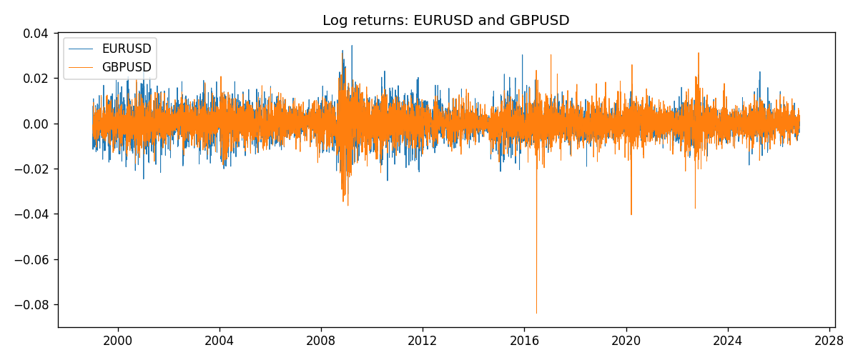

System charts (shared)
Correlation matrix

Distance matrix

PCA eigenvalues

GFEVD theta_tilde


Data report
First 15 matched rows
time | EURUSD_log_return | GBPUSD_log_return
1999-01-05 | -0.0048360507 | -0.0028966287
1999-01-06 | -0.011547966 | -0.00060452184
1999-01-07 | 0.0076280636 | -0.002118709
1999-01-08 | -0.010902799 | -0.0058954193
1999-01-11 | -0.007103287 | -0.0056851331
1999-01-12 | 0.0045103728 | 0.0022657001
1999-01-13 | 0.010845346 | 0.0091330396
1999-01-14 | 0 | 0.0019376331
1999-01-15 | -0.010153245 | -0.0017558204
1999-01-18 | 0.0036256946 | 0.0012112405
1999-01-19 | -0.00017235436 | 0.0018745281
1999-01-20 | -0.0031939256 | -0.0049053846
1999-01-21 | 0.0030215416 | 0.0031518998
1999-01-22 | -0.0012075213 | 0.0024781662
1999-01-25 | -0.0030251979 | 0.0012066366
Last 15 matched rows
time | EURUSD_log_return | GBPUSD_log_return
2026-10-13 | 0.0037402957 | 0.0036434319
2026-10-14 | -0.0037582255 | -0.0049164679
2026-10-15 | 0.0056053107 | 0.0065976411
2026-10-16 | 0.0017724895 | 0.0037592051
2026-10-19 | -0.0025394633 | -0.0017500314
2026-10-20 | 0.0023881672 | 0.0055923442
2026-10-21 | -0.00032046717 | 0.0012476328
2026-10-22 | -0.0015949606 | 0.00022396082
2026-10-23 | -0.001338521 | -0.0021146949
2026-10-26 | -0.0022706559 | -0.0024340661
2026-10-27 | -0.004152342 | -0.0023648393
2026-10-28 | 0.0022262927 | 0.0015771808
2026-10-29 | 0.0022571351 | 0.0035881935
2026-10-30 | -0.0011458446 | 0.0013450605
2026-11-02 | 0.002120569 | 0.0010971256

